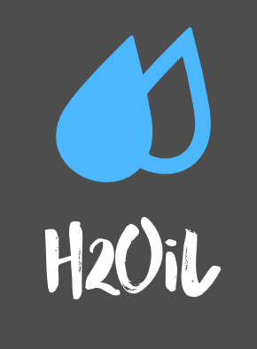

**Join our community in this Online Platform to fight against Oil Spills. Make use of our multiple tools to share your knowledge with others and to make a difference!**

* **Register and Login;**
* **Create and read posts;**
* **Read the Latest News about Oil Spills and Black Tides;**
* **Volunteer to help with this problem.**